**Chapter 6**

**RESULTS**

**6.1 Initial screen**

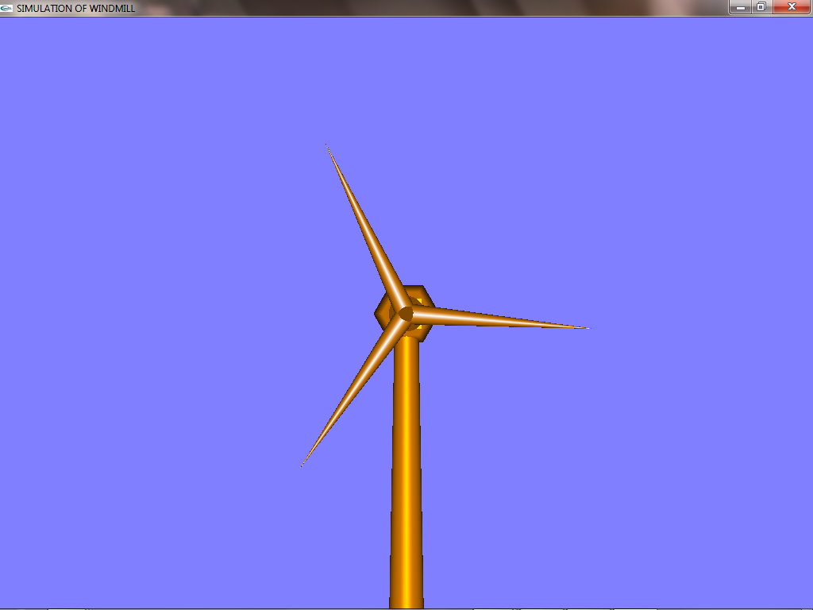

Fig 6.1: Initial screen

The above diagram shows the snapshot having the windmill. The objects are of windmill shape and are placed towards the right of the display window. And the display window is of size (600,600).